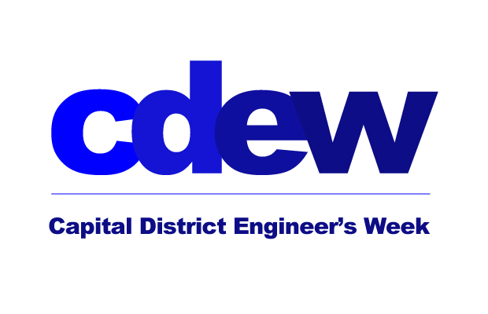

The Capital District’s Celebration of National Engineers Week
February 13 & 14, 2025 – Online Webinar Series

Event Sponsorship Opportunities
Deadline January 13, 2025

All sponsors will be recognized on:
The Event Notice with your Company Logo
You get an 8x11 page in our electronic booklet going out to all attendees.

All Sponsorships are $250
$100 each additional page
Items below must be received no later than Jan. 13th
- Company logo must be sent as a jpeg file.
- The 8x11 page must be received as a PDF file.

All files & this form can be emailed to Jen Miller – jamiller@nysspe.org

Firm Name

Contact: |  | Phone #

Email Address:

Payment Information: Make checks payable to: The Foundation for Engineering Education, (FEE)
Mail form to: FEE, c/o Laura Pellizzi, Finance Director, 477 Miller Place Rd., Miller Place, NY 11764
Capital District Engineers Week – c/o FEE, Jen Miller • 518-577-1132 • jamiller@nysspe.org• CapitalDistrictEweek.org
If mailing in form email a copy to Jen Miller – jamiller@nysspe.org

Please Charge my VISA, Mastercard, Discover, A/E (complete information below) – PLEASE PRINT CLEARLY
Card holder’s Name: |  |  | Signature:
Card holder’s Address: |  |  |  |  | Zip Code:

Email receipt to (if different from above):

Card # |  | - |  | - |  | - |  |  | Exp Date |  | /

3/4 Digit Security code:

For any questions on the above information please contact Jennifer Miller, E-Week
Coordinator at: 518-577-1132 or email questions and the form to: jamiller@nysspe.org

