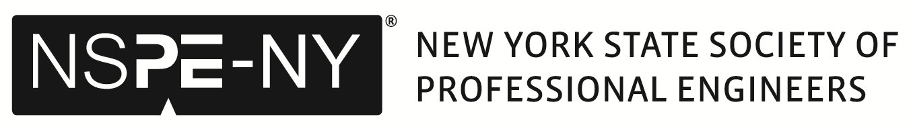
NYS Approved Sponsor under PIE
Capital District's 45th Celebration of NATIONAL ENGINEERS WEEK
February 13 & 14, 2025 – Online Webinars through Zoom

Seminar Application Form - Due by: November 1, 2024
All Required Supporting Materials Due by: December 1, 2024

Name & designation: |  | Phone: |  | Company/Org.:

Address: |  | Date/Location: | Feb. 13 or 14, 2025 – Online Webinars

E-mail (s):

Seminar Title

Seminar Already approved with PIE? No need to send materials below. Enter your approval #

Description of seminar for event advertising:

Required Supporting Material Presentation Duration (minutes): 1 Hour (50 to 60 mins)
Due: No later than December 1, 2024, please email materials requested below to: jamiller@nysspe.org.

1. A resume or bio is attached for each speaker (to demonstrate the speaker’s qualifications to speak on the topic).
2. Your Presentation with logos on 1st & last slides only. You can send this as a PDF file with 4-6 slides to a sheet (Preferred).
3. Assessment of learning (Send your questions with True/False or 2-3 answers in a separate document, we will set up polling questions in Zoom)

NOTE: We need TECHNICAL seminars, NOT a Sales Pitch. Company logos can be on the first two and last two slides. You MUST have at least 50 minutes of contact time to qualify for PDH approval. The Engineers Week Planning Committee reserves the right to accept or reject any seminar that does not receive PDH approval if determined not to be the right fit for our event.
‪Program Area:‪ | Buildings |  | Bridge |  | Civil |  | Chemical |  | Concrete
‪Program Area:‪ | Electrical |  | Energy |  | Environmental |  | Ethics |  | Geotechnical
‪Program Area:‪ | Mechanical |  | Structural |  | Transportation |  | Other (describe)

Introductory = New to the engineering field, with little or no experience such as students. | Intermediate = A few years of experience in the field of engineering with a desire to build on it. | Advanced = A “seasoned” engineering profession with many years experience.

Submit this form with supporting materials to: Jennifer Miller, Coordinator at jamiller@nysspe.org

Seminar Approval Information: This seminar will ONLY be approved by NYSSPE for the E-Week Event ONLY. If you want to offer this seminar again, please contact Jen Miller at NYSSPE, Phone: 518-577-1132 or email: jamiller@nysspe.org for more information.

